页面入口放在Video Tutorials的后面
页面版式
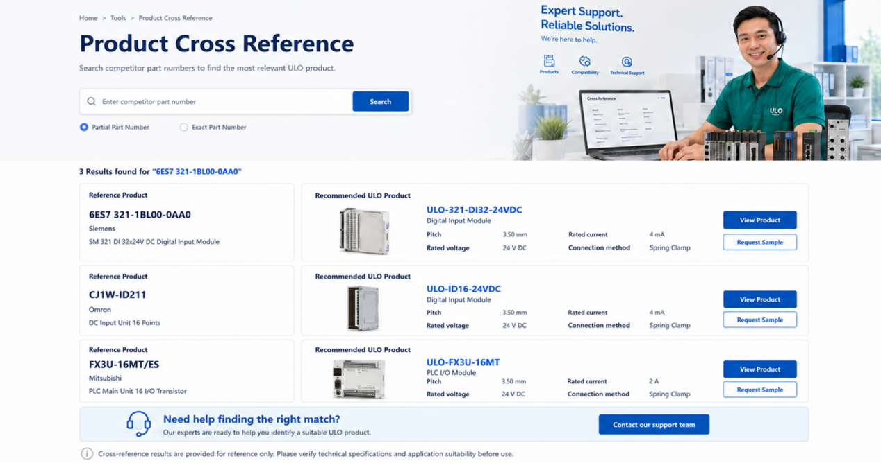
页面入口标题：Cross Reference
页面主标题:Product Cross Reference
副标题：Enter a manufacturer part number to find comparable ULO products.
搜索框引导词：Enter a part number
搜索模式：Partial Part Number / Exact Part Number
卡片左侧顶部Recommended ULO Product改成Suggested ULO Product
底部标签标题：Need help finding the right match?
副标题：Send us the part number and our team will help identify a suitable ULO product for your application.

小字免责申明改成：Third-party product names and part numbers are used for reference purposes only. Cross-reference results are provided for product selection guidance and do not imply affiliation or exact equivalence. Please verify technical specifications and application suitability before use.

